

KAUNAS UNIVERSITY OF TECHNOLOGY

FACULTY OF INFORMATICS

T120B169 App Development for Smart Mobile Systems

*Fishing Time*

|  |
| --- |
| *IFZm-1, Emilija Kravčenko:* |
| Date: *2024.03.03* |

Kaunas, 2024

Tables of Contents

Description of Your app 3

Functionality of your app 4

List of functions 4

Solution 5

Task #1. Displaying action and navigation bar only on swipe 5

Task #2. Navigation between fragments 6

Task #3. Reacting to button clicking and image clicking. Remove or change UI component from the activity when a button is clicked. 7

Task #4. Moving an image with a finger 8

Task #5. Saving game state when flipping screen 10

Reference list 12

# **Description of Your app**

1. Cozy fishing game
2. Description: Ekrane matoma viena plūdinė meškerė. Kai pamatai kad kimba, iš plūdės elgesio, paspaudi ant meškerės. Paspaudus matai pritrauktą  meškerės vaizdą per vidurį. Gali paspausti mygtuką kirsti ir jei užkimba pritraukinėji laimikį spaudžiant dešinį mygtuką o su kairiu pirštu kontroliuoji meškerę, kaip nori, paslenkant ją ekrane, kuri lenkiasi nuo žuvies. Jei sėkmingai pritraukei žuvį pamatai iššokusiame lange ką pagavai ir gauni pinigų. Už pinigus gali nusipirkti naujas žvejojimo vietas ir keliauti tarp jų. Jei nesėkmingai pritraukei ir žuvis nutrūksta pamatai iššokusiame lange, kad tau nepavyko ir vėl matai vieną meškerę.

# **Functionality of your app**

## **List of functions**

1. Displaying action and navigation bar only on swipe
2. Navigation between fragments
3. Reacting to button clicking and image clicking. Remove or change UI component from the activity when a button is clicked
4. Moving an image with a finger
5. Saving game state when flipping screen

# **Solution**

## **Task #1. Displaying action and navigation bar only on swipe**

After opening the game user does not see an action and navigation bar unless they swipe from the very top down or from the very bottom up in vertical phone view or from the very top down or from the furthest right to left in horizontal phone view. After swiping, the user has a few seconds to use those bars before they disappear.

Figure 1. Screenshot #1

Figure 2. Screenshot #2

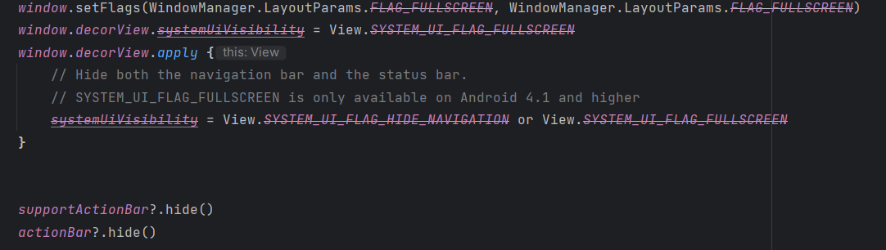

Figure 3. Source code #1

## **Task #2. Navigation between fragments**

Navigation Graph controls movement between fragments. After pressing on a button or an image navigation graph is called to make transition to next fragment. Also automatically works when pressing back button and takes user to previous fragment. The Back button action can be reprogrammed.

Figure 4. Screenshot #3

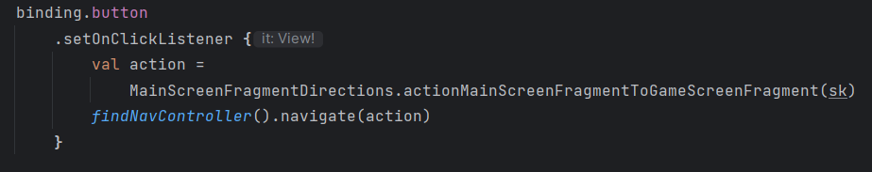

Figure 5. Source code #2

## **Task #3. Reacting to button clicking and image clicking. Remove or change UI component from the activity when a button is clicked.**

After clicking on a button or some images a function is called. For example: Clicking on button “Kirsti” makes it disappear and makes an image appear. Long clicking on reel image calls another function that counts the number of correct reels, rotates image.

Figure 6. Screenshot #4

Figure 7. Screenshot #5

Figure 8. Source code #3

Figure 9. Source code #4

## **Task #4. Moving an image with a finger**

After successfully striking the player can move an image of a rod across the screen but can’t move it completely out of sight. Movement area depends on screen size and position. Image position is recalculated after flipping the screen.

Figure 10. Screenshot #6

Figure 11. Screenshot #7

Figure 12. Source code #5

Figure 13. Source code #6

## **Task #5. Saving game state when flipping screen**

While catching fish, if a screen is flipped, game progress is saved. Visibility, rotation, position of buttons and images, and the number of successful reels are all saved and recreated after flipping the screen. This way, the game remembers if you already correctly moved the rod and lets you reel in flipped view. Code reference was taken from Source#[[1](https://www.youtube.com/watch?v=TcTgbVudLyQ)].

Figure 14. Screenshot #8

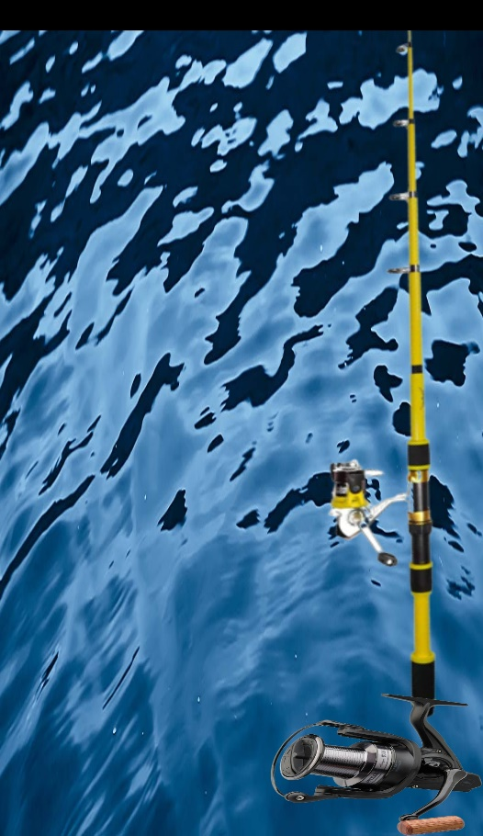

Figure 15. Screenshot #9

Figure 16. Source code #7

Figure 17. Source code #8

# **Reference list**

1. Source #1. https://www.youtube.com/watch?v=TcTgbVudLyQ